**Unix / Linux – File Permission / Access Modes**

|  |  |  |
| --- | --- | --- |
| **Number** | **Octal Permission Representation** | **Ref** |
| 0 | No permission | --- |
| 1 | Execute permission | --x |
| 2 | Write permission | -w- |
| 3 | Execute and write permission: 1 (execute) + 2 (write) = 3 | -wx |
| 4 | Read permission | r-- |
| 5 | Read and execute permission: 4 (read) + 1 (execute)=5 | r-x |
| 6 | Read and write permission: 4 (read) + 2 (write) = 6 | rw- |
| 7 | All permissions: 4 (read) + 2 (write) + 1 (execute) = 7 | rwx |

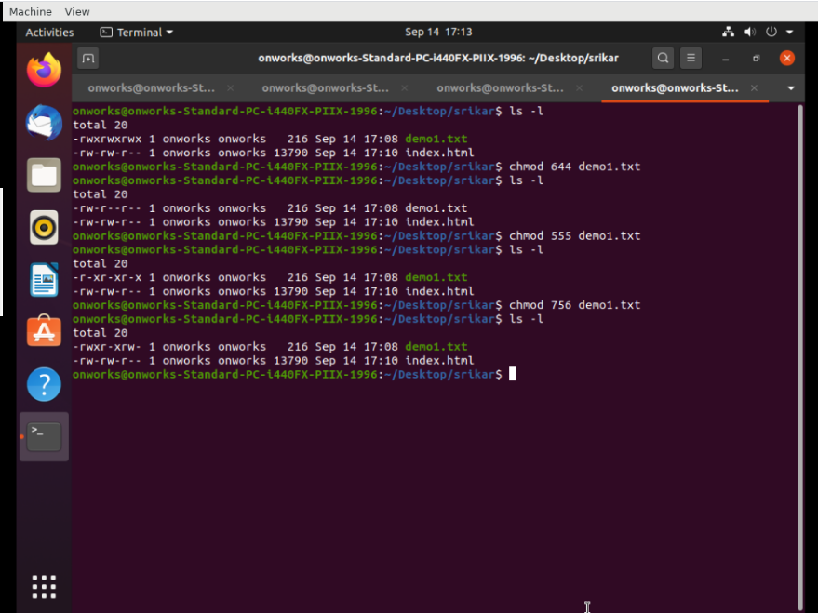

**Cat Command:**

Cat(concatenate) command is very frequently used in Linux. It reads data from the file and gives their content as output. It helps us to create, view, concatenate files. So let us see some frequently used cat commands.

Example:

1. Input: cat demo1.txt

Text: Welcome to THBS

Output: Welcome to TBS

1. Text in demo1.txt: Welcome to THBS

Test in demo2.txt: Good Morning

Welcome to the new day

We welcome you to this organization

Input: cat demo1.txt > demo2.txt

Output: Welcome to THBS

1. Text in demo3.txt: Good Morning

Welcome to the new day

We welcome you to this organization

Input: cat -n demo3.txt

Output: 1 Good Morning

2 Welcome to the new day

3 We welcome you to this organization

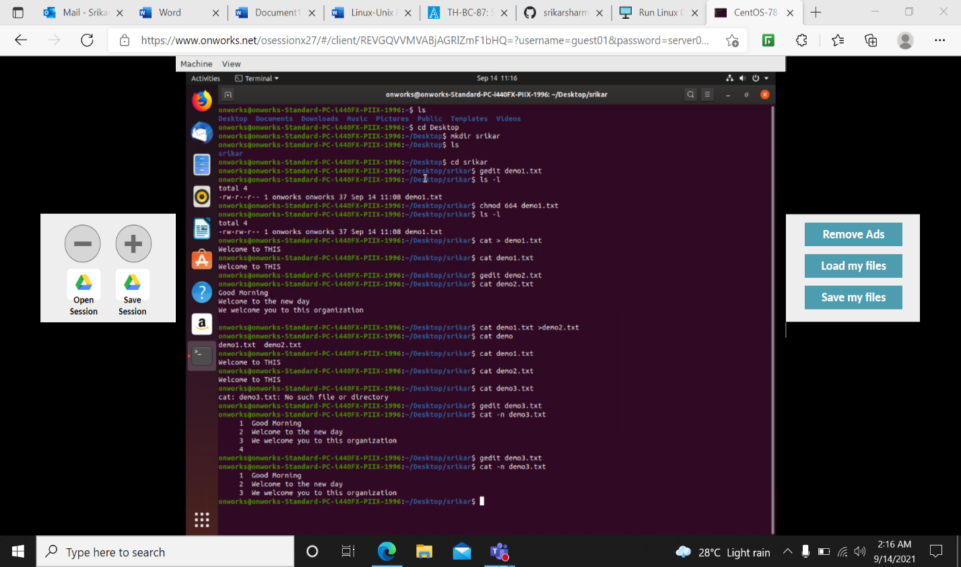

INTRODUCTION TO VI/VIM COMMAND

Vi stands for Visual. It is a text editor that is an early attempt to a visual text editor.

Vim stands for Vi IMproved. It is an implementation of the Vi standard with many additions. It is the most commonly used implementation of the standard. Most Linux distributions come with Vim already installed.

To enter Insert mode, press i. In Insert mode, you can enter text, use the Enter key to go to a new line, use the arrow keys to navigate text, and use vi as a free-form text editor. To return to Command mode, press the Esc key once.

To save a file, you must first be in Command mode. Press Esc to enter Command mode, and then type: wq to write and quit the file. The other, quicker option is to use the keyboard shortcut ZZ to write and quit.

To the non-vi initiated, write means save, and quit means exit vi. If you’ve made mistakes along the way in your editing and want to back out (abandon) all non-saved changes, enter Command mode by pressing Esc and type :q! This command quits without saving any changes and exits vi.

EXAMPLE: vi demo1.txt

1. Screenshot 1: :wq – saves the changes, and exits Vim

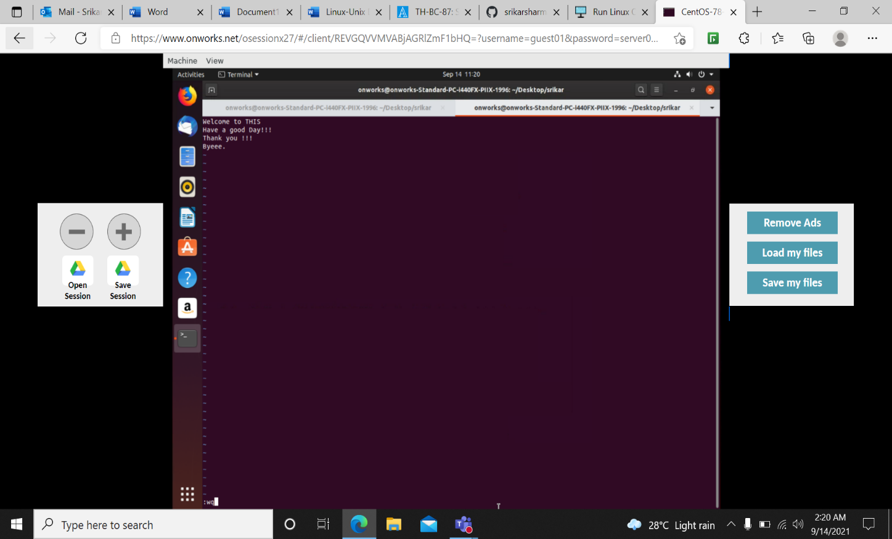

1. Screenshot 2: Esc – switch to command mode

:w – write out changes that were made

1. :q – exit Vim
2. :q! – exit Vim and discard any changes
3. :x – save the changes made, and exits Vim

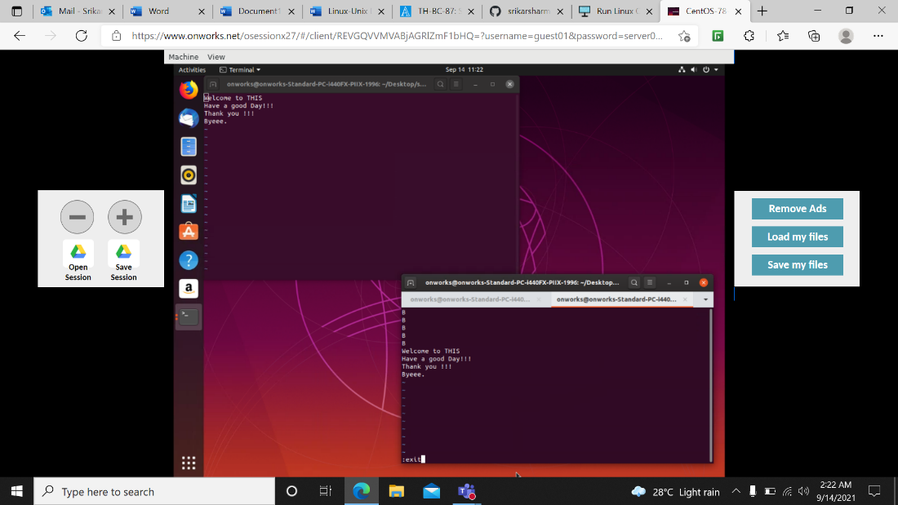

Screenshot 3: d5-> Delete first 5 lines

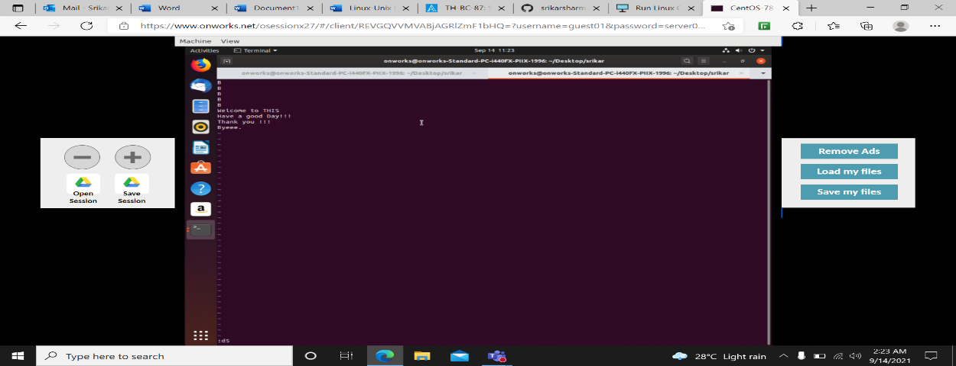

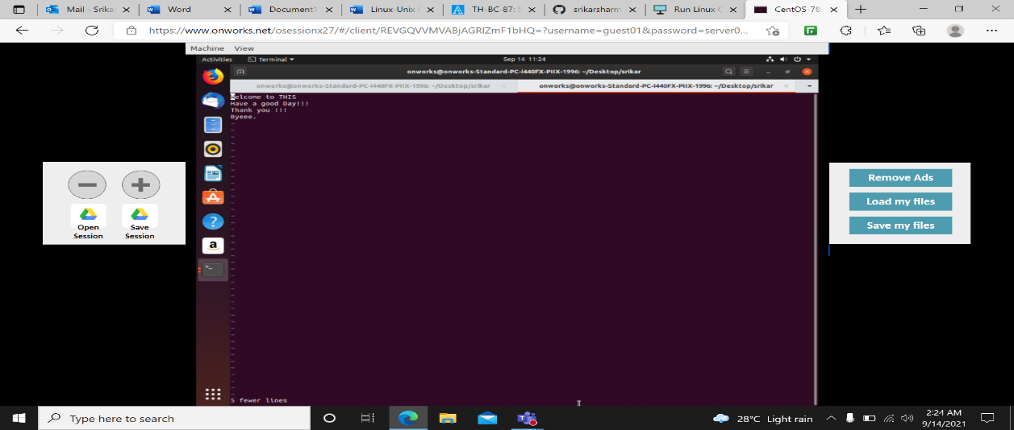

:set number -> A column of sequential line numbers will then appear at the left side of the screen. Each line number references the text located directly to the right.

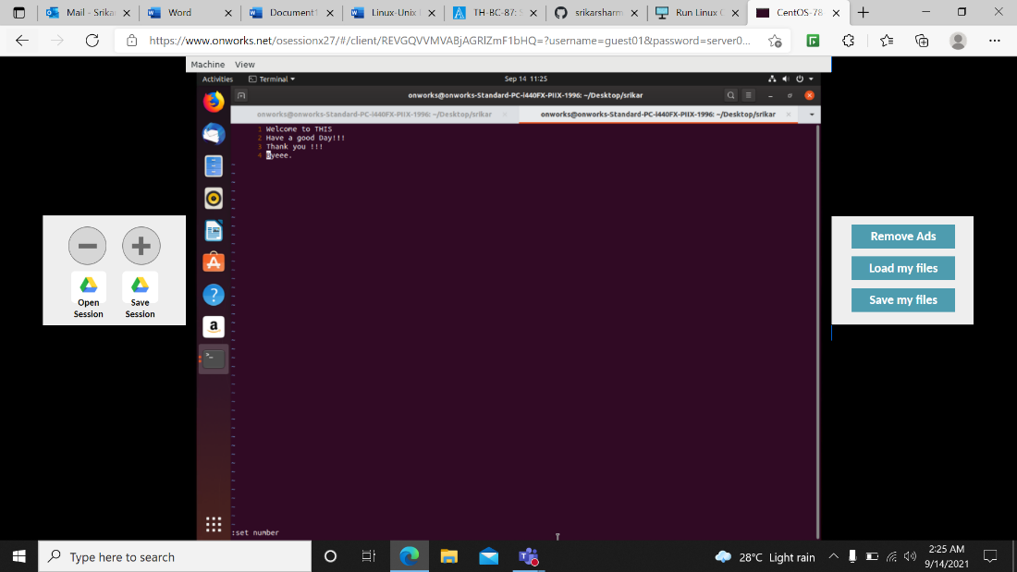

dd – Delete line

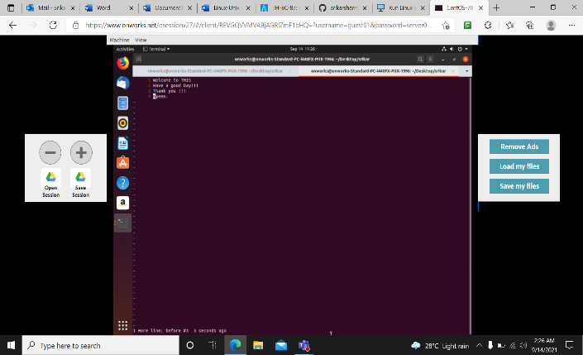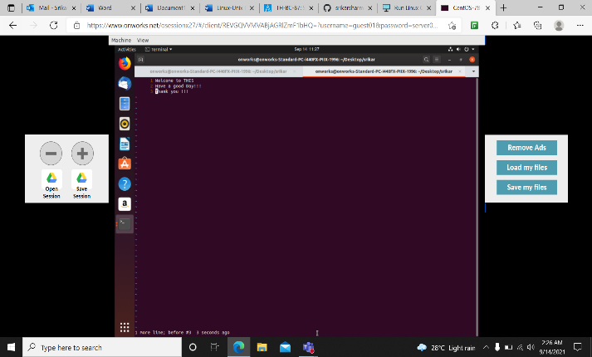

1. Before Applying dd command B) After Applying dd command

Undo (u)

u – Undo last change U – Undo all changes to the entire line

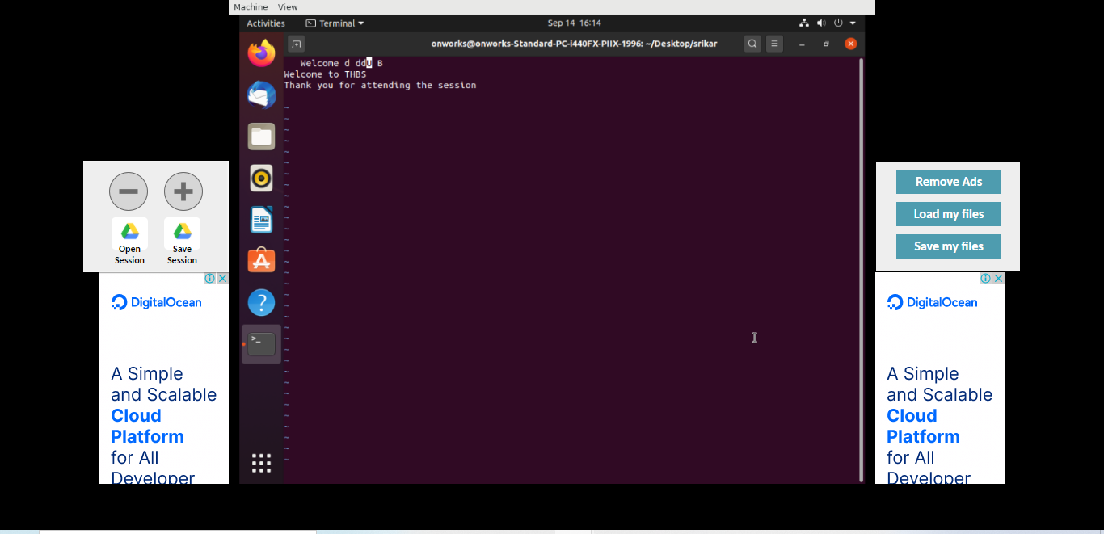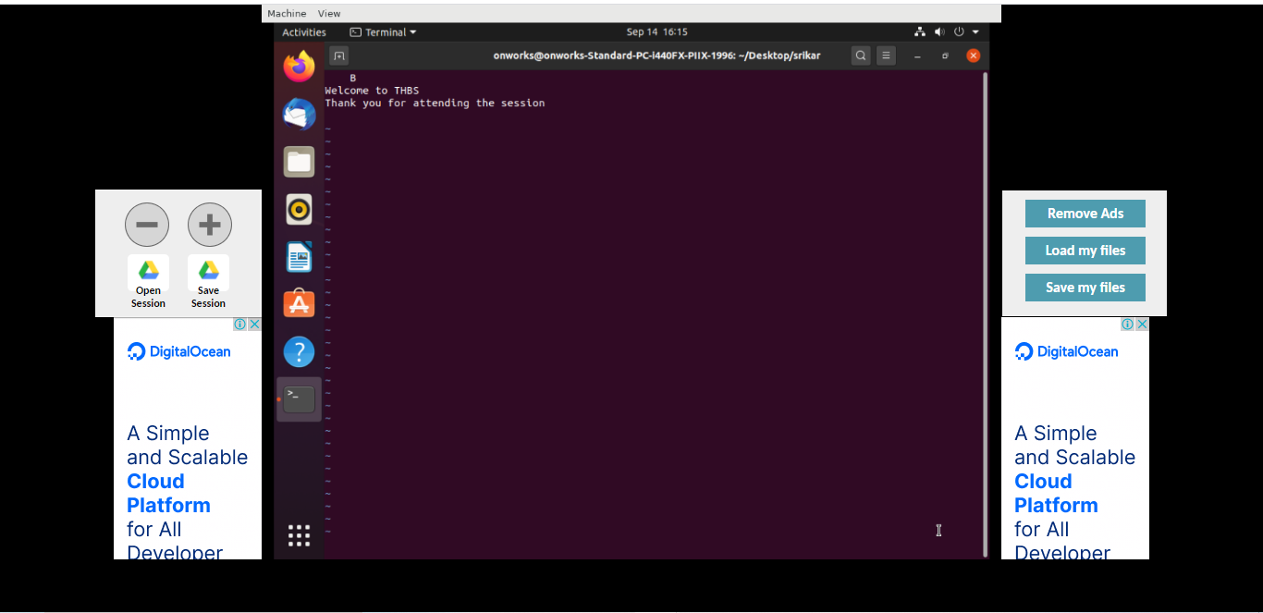

E -> (e) End of each word

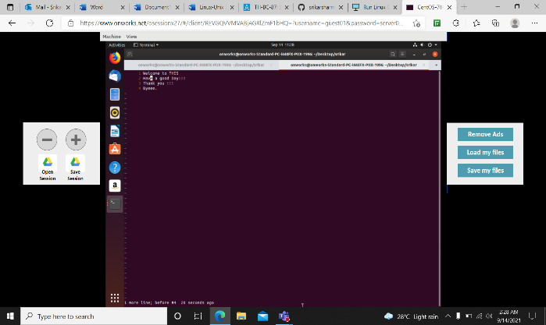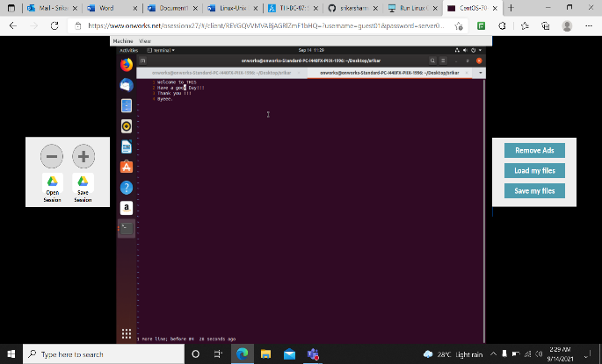

:r -> Replace character

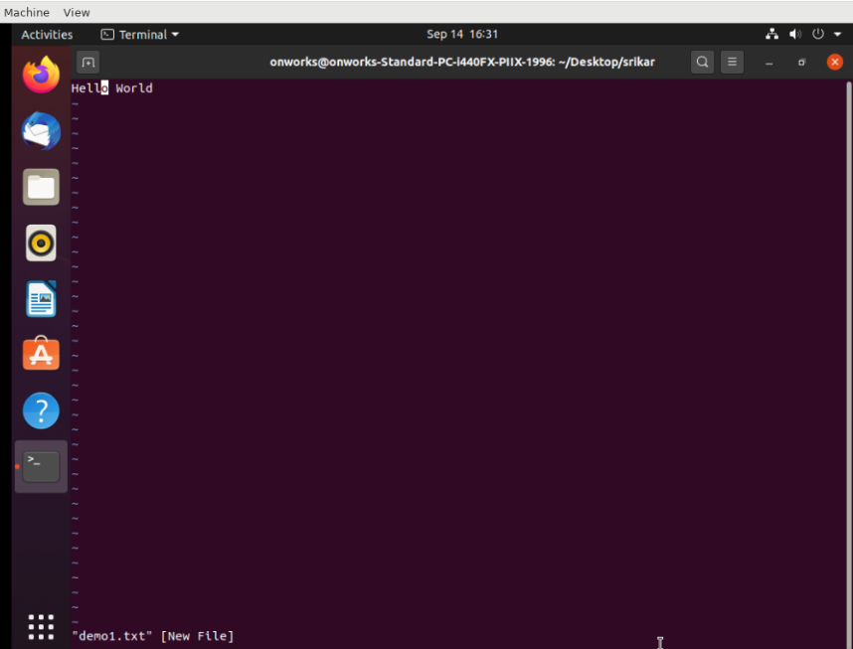 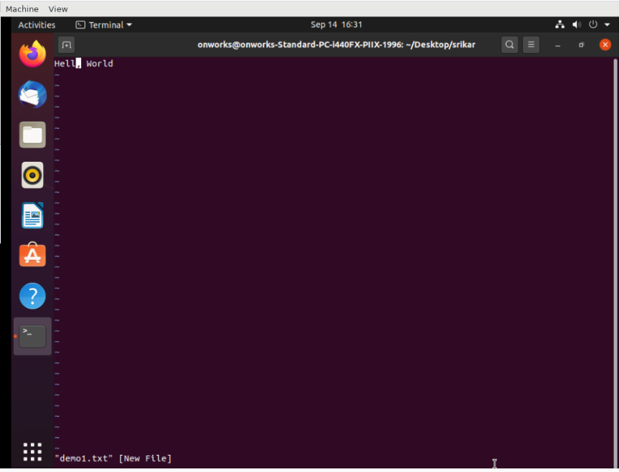

x – Delete character at the cursor

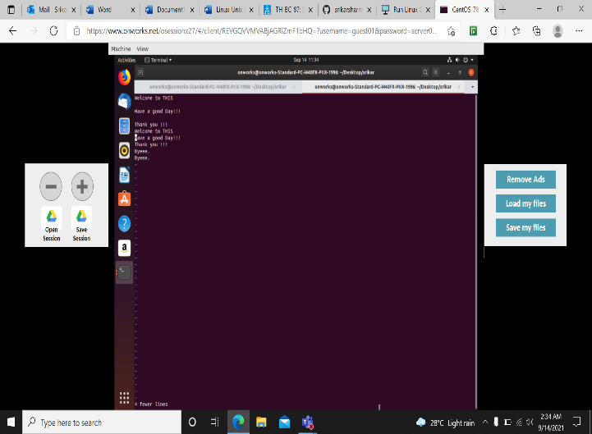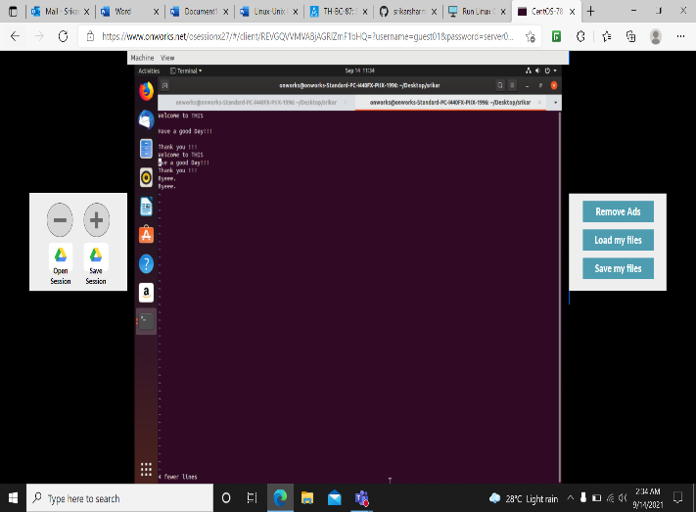

Before performing x After performing x

yy – yank the current line or copy the current line , including the newline character at the end of the line

p – paste the copied line in new line

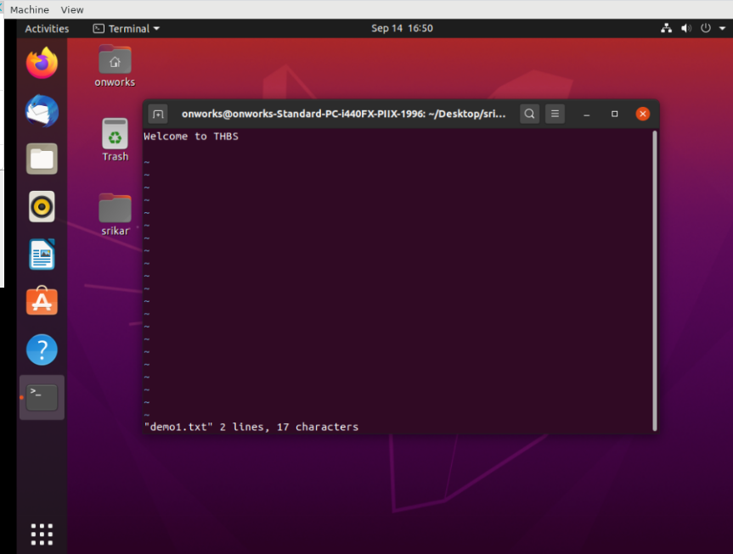

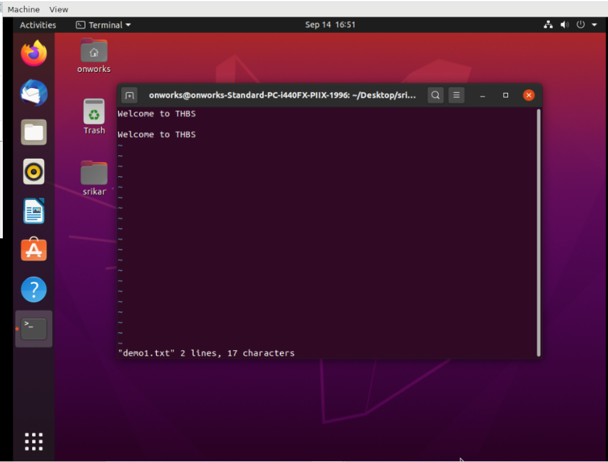

dw – Delete word

1. Before applying dw

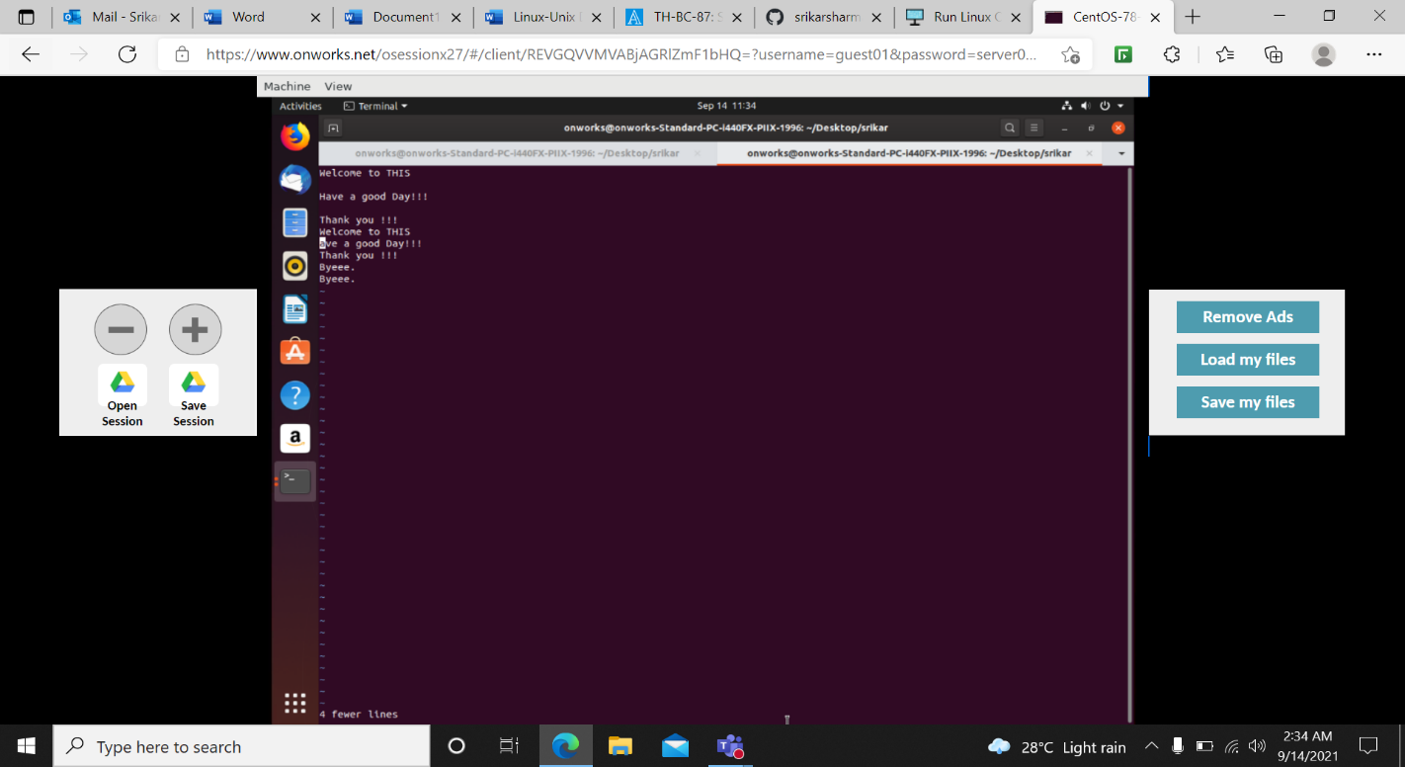

1. After applying dw

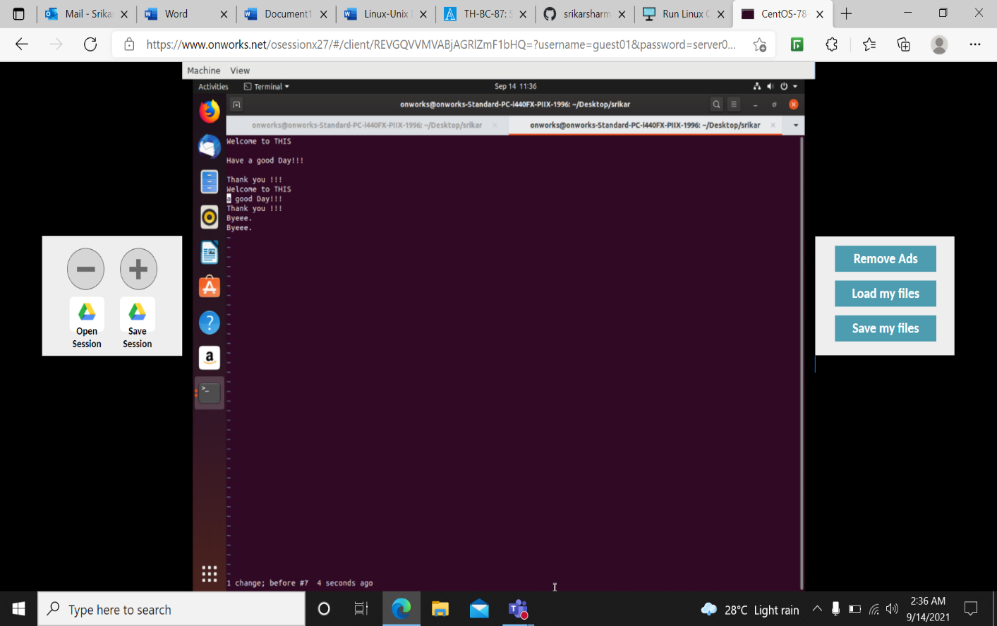

Sort: SORT command is used to sort a file, arranging the records in a particular order.

Uniq: The uniq command in Linux is a command line utility that reports or filters out the repeated lines in a file.

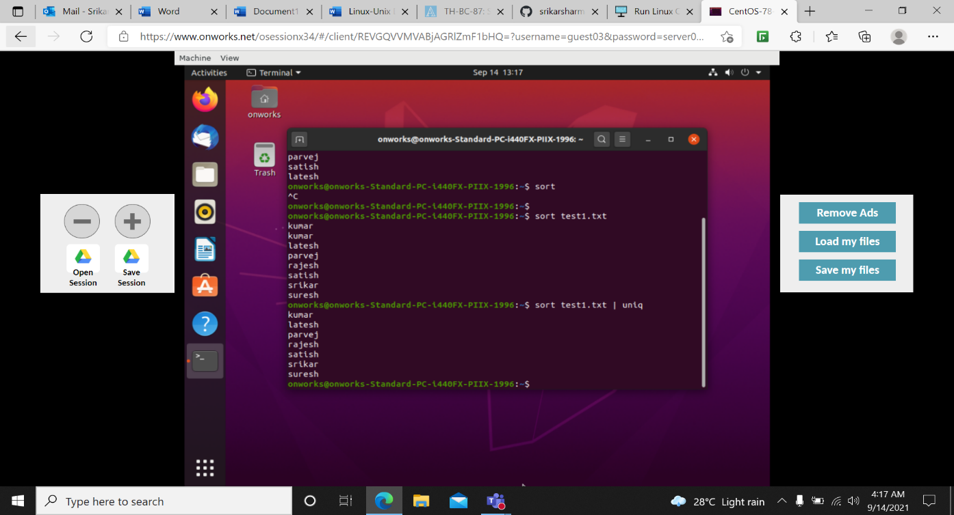

Dir: dir command in Linux is used to list the contents of a directory.

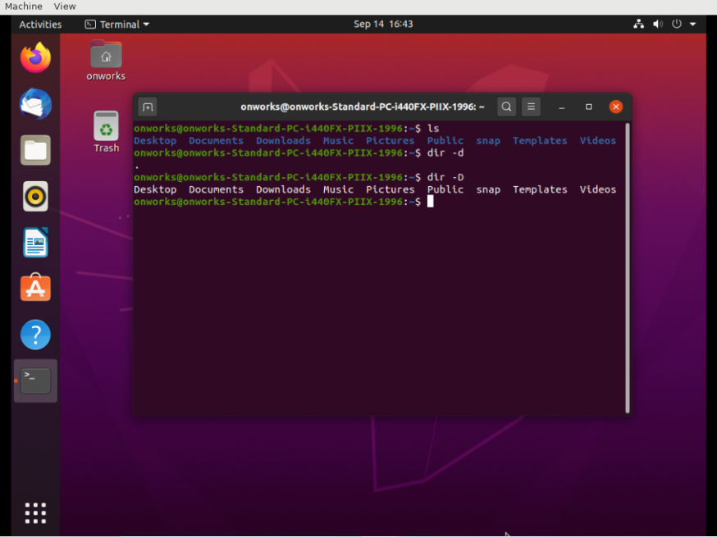

Bg anf fg

The fg command, short for the foreground, is a command that moves a background process on your current Linux shell to the foreground.

This contrasts the bg command, short for background, that sends a process running in the foreground to the background in the current shell.

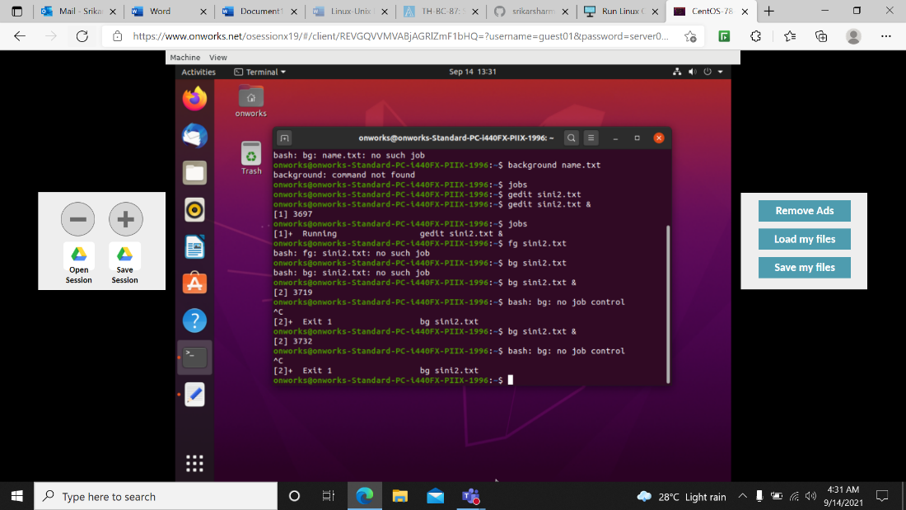

Wget: Wget command is a Linux command line utility that helps us to download the files from the web. We can download the files from web servers using HTTP, HTTPS and FTP protocols.

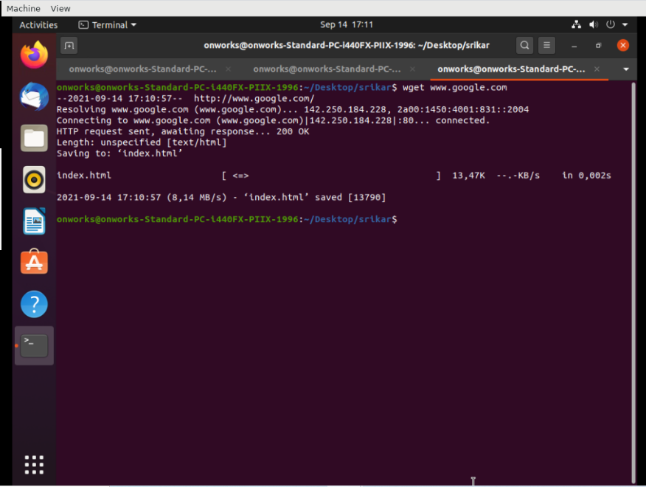

History – The command is simply called history, but can also be accessed by looking at your . bash_history in your home folder

Uname -v – -v option: It prints the version of the current kernel.

Uname - The command “uname” displays the information about the system.

Whoami - Displays user, group and privileges information for the user who is currently logged on to the local system.

Hostname - A hostname is a name which is given to a computer and it attached to the network. Its main purpose is to uniquely identify over a network.

Alias - alias command instructs the shell to replace one string with another string while executing the commands.

When we often have to use a single big command multiple times, in those cases, we create something called as alias for that command. Alias is like a shortcut command which will have same functionality as if we are writing the whole command.

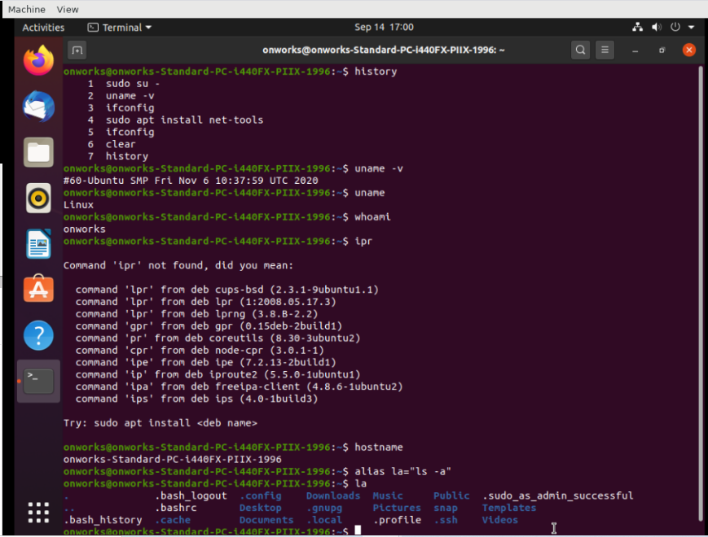

Head - head command will output the first part of the file.

Tail - tail command will print the last part of the file.

Both commands write the result to standard output.

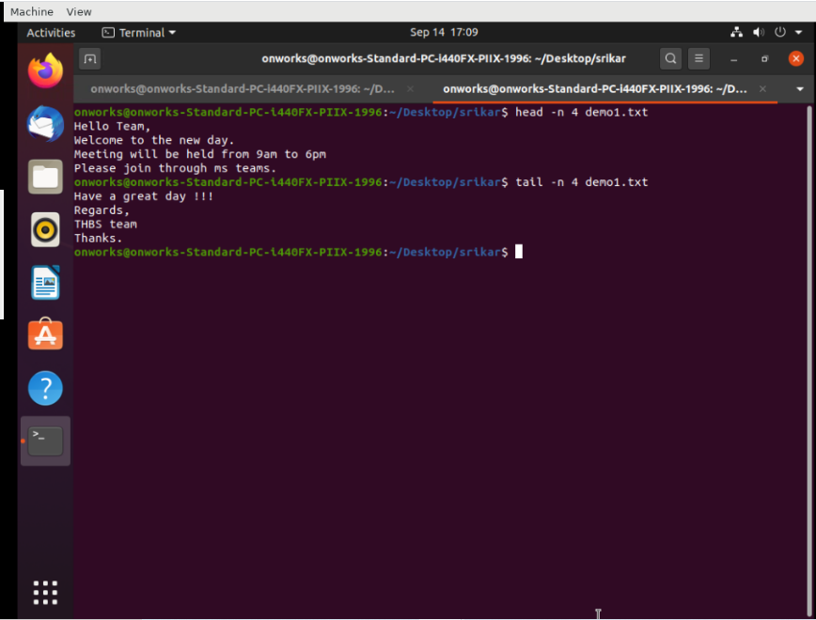

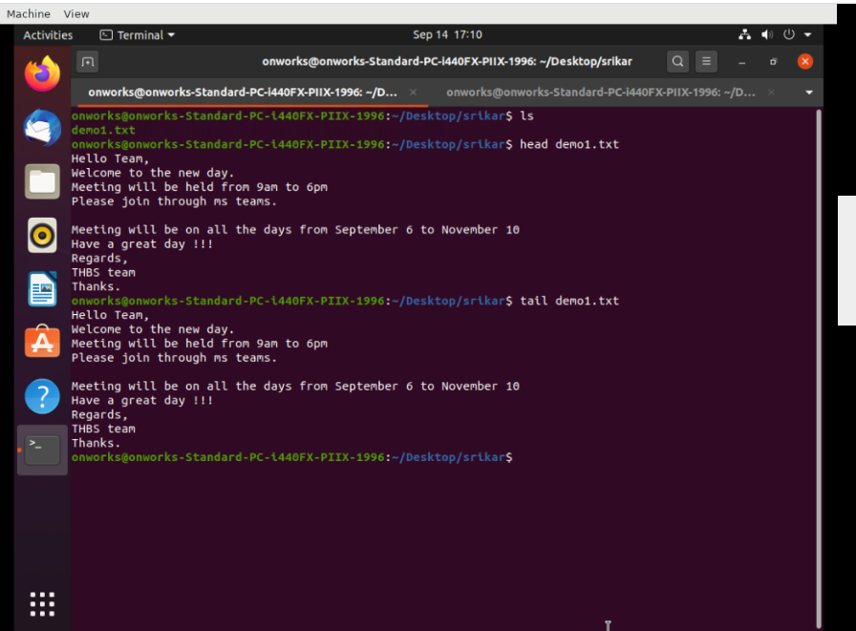

Grep: The grep filter searches a file for a particular pattern of characters, and displays all lines that contain that pattern. The pattern that is searched in the file is referred to as the regular expression.

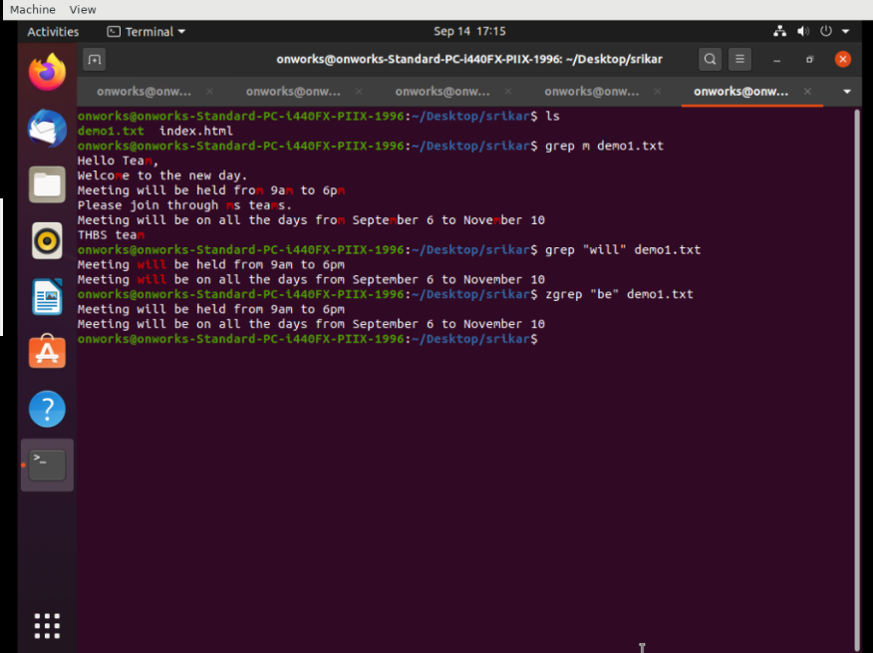

Killall: The killall command in Linux is a utility command used for killing any running process on the system based on a given name.

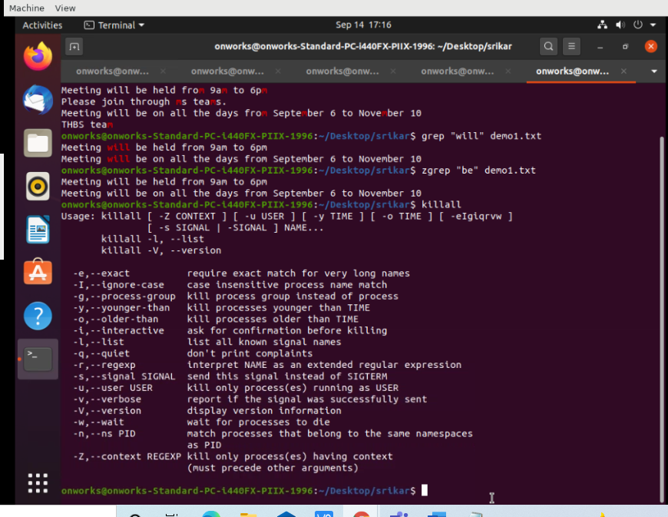

Uname: The command ‘uname‘ displays the information about the system.

1. -a option: It prints all the system information in the following order: Kernel name, network node hostname, kernel release date, kernel version, machine hardware name, hardware platform, operating system.

Syntax: $uname -a

2. -s option: It prints the kernel name.

Syntax: $uname -s

3. -n option: It prints the hostname of the network node(current computer).

Syntax: $uname -n

4. -r option: It prints the kernel release date.

Syntax: $uname -r

5. -v option: It prints the version of the current kernel.

Syntax: $uname -v

6. -m option: It prints the machine hardware name.

Syntax: $uname -m

7. -p option: It prints the type of the processor.

Syntax: $uname -p

8. -i option: It prints the platform of the hardware.

Syntax: $uname -i

9. -o option: It prints the name of the operating system.

Syntax : $uname -o

